Area and Perimeter of Triangles

Concept
In this concept, you will learn how to calculate the area and perimeter of a triangle.

Guidance
The formula for the area of a triangle is half the area of a parallelogram.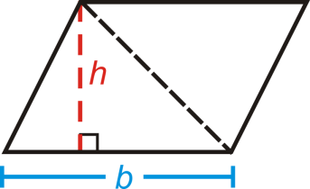
Area of a Triangle: .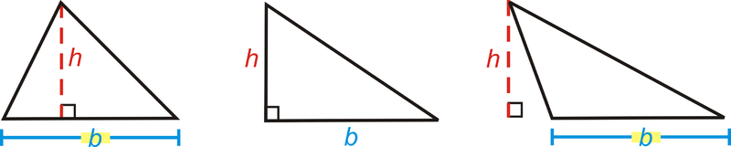

Example A
Find the area of the triangle.
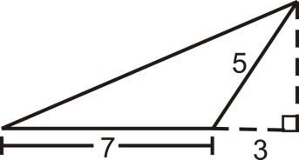
To find the area, we need to find the height of the triangle. We are given two sides of the small right triangle, where the hypotenuse is also the short side of the obtuse triangle.
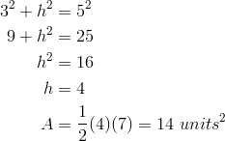

Example B
Find the perimeter of the triangle in Example A.
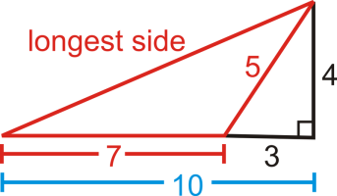
To find the perimeter, we need to find the longest side of the obtuse triangle. If we used the black lines in the picture, we would see that the longest side is also the hypotenuse of the right triangle with legs 4 and 10.
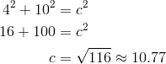 The perimeter is

Example C
Find the area of a triangle with base of length 28 cm and height of 15 cm.
The area is .

Vocabulary
Perimeter is the distance around a shape. The perimeter of any figure must have a unit of measurement attached to it. If no specific units are given (feet, inches, centimeters, etc), write “units.” Area is the amount of space inside a figure. Area is measured in square units.

Guided Practice
Use the triangle to answer the following questions.
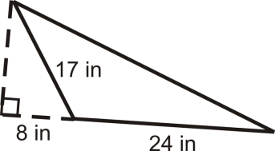
- Find the height of the triangle.
- Find the perimeter.
- Find the area.

Answers:
1. Use the Pythagorean Theorem to find the height.
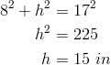
2. We need to find the hypotenuse. Use the Pythagorean Theorem again.
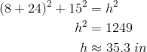
The perimeter is .
3. The area is .

Practice
Use the triangle to answer the following questions.
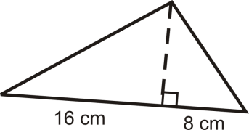
- Find the height of the triangle by using the geometric mean.
- Find the perimeter.
- Find the area.
Find the area of the following shape.
- 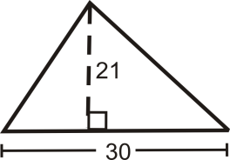
- What is the height of a triangle with area and a base of 24 m?
In questions 6-11 we are going to derive a formula for the area of an equilateral triangle.
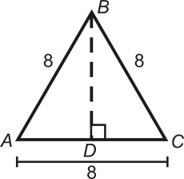
- What kind of triangle is ? Find and .
- Find the area of .
- If each side is , what is and ?
- If each side is , find the area of .
- Using your formula from #9, find the area of an equilateral triangle with 12 inch sides.
- Using your formula from #9, find the area of an equilateral triangle with 5 inch sides.

Area and Perimeter of Rectangles

Concept
In this concept, you will learn how to calculate area and perimeter of rectangles.

Guidance
To find the area of a rectangle, calculate , where is the base (width) and is the height (length). The perimeter of a rectangle will always be .
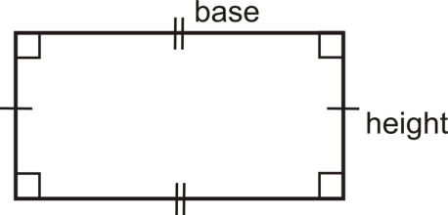
If a rectangle is a square, with sides of length , then perimeter is and area is .
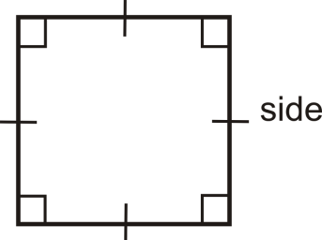

Example A
Find the area and perimeter of a rectangle with sides 4 cm by 9 cm.
The perimeter is . The area is .

Example B
Find the area and perimeter of a square with side 5 in.
The perimeter is and the area is .

Example C
Find the area and perimeter of a rectangle with sides 13 m and 12 m.
The perimeter is . The area is .

Vocabulary
Perimeter is the distance around a shape. The perimeter of any figure must have a unit of measurement attached to it. If no specific units are given (feet, inches, centimeters, etc), write “units.” Area is the amount of space inside a figure. Area is measured in square units.

Guided Practice
1. The area of a square is . Find the perimeter.
2. Draw two different rectangles with an area of .
3. Find the area and perimeter of a rectangle with sides 7 in and 10 in.

Answers:
1. To find the perimeter, we need to find the length of the sides.
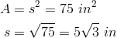
From this, .
2. Think of all the different factors of 36. These can all be dimensions of the different rectangles.
Other possibilities could be , and .
3. Area is . Perimeter is .

Practice
- Find the area and perimeter of a square with sides of length 12 in.
- Find the area and perimeter of a rectangle with height of 9 cm and base of 16 cm.
- Find the area and perimeter of a rectangle if the height is 8 and the base is 14.
- Find the area and perimeter of a square if the sides are 18 ft.
- If the area of a square is , find the perimeter.
- If the perimeter of a square is 24 in, find the area.
- The perimeter of a rectangle is 32. Find two different dimensions that the rectangle could be.
- Draw two different rectangles that haven an area of .
- True or false: For a rectangle, the bigger the perimeter, the bigger the area.
- Find the perimeter and area of a rectangle with sides 17 in and 21 in.

Area and Perimeter of Trapezoids

Concept
In this concept, you will learn how to find the area and perimeter of a trapezoid.

Guidance
A trapezoid is a quadrilateral with one pair of parallel sides. The parallel sides are called the bases and we will refer to the lengths of the bases as and . The perpendicular distance between the parallel sides is the height of the trapezoid. The area of a trapezoid is where is always perpendicular to the bases.
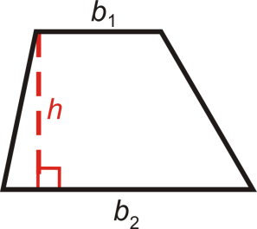

Example A
Find the area of the trapezoid below.
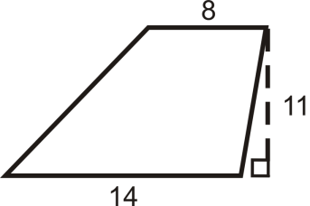
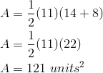

Example B
Find the area of the trapezoid below.
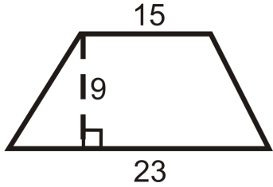
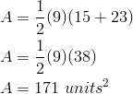

Example C
Find the perimeter and area of the trapezoid.
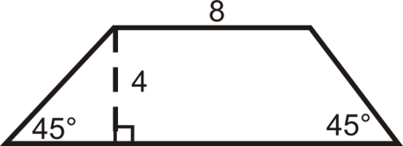
Even though we are not told the length of the second base, we can find it using special right triangles. Both triangles at the ends of this trapezoid are isosceles right triangles, so the hypotenuses are and the other legs are of length 4.

Vocabulary
Perimeter is the distance around a shape. The perimeter of any figure must have a unit of measurement attached to it. If no specific units are given (feet, inches, centimeters, etc), write “units.” Area is the amount of space inside a figure. Area is measured in square units. A trapezoid is a quadrilateral with one pair of parallel sides.

Guided Practice
Find the area of the following shapes. Round your answers to the nearest hundredth.
- 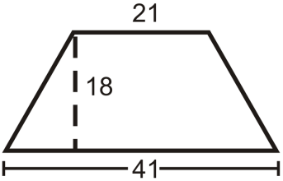
- 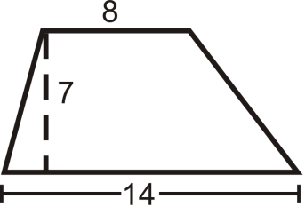
- 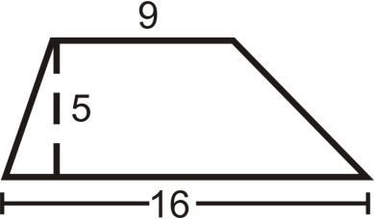

Answers
Use the formula for the area of a trapezoid.
1. .
2. .
3. .

Practice
Find the area and perimeter of the following shapes. Round your answers to the nearest hundredth.
- 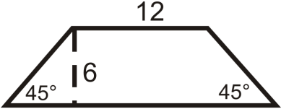
- 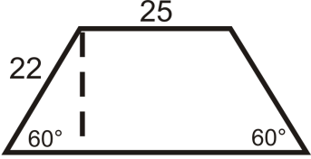
Find the area of the following trapezoids.
- Trapezoid with bases 3 in and 7 in and height of 3 in.
- Trapezoid with bases 6 in and 8 in and height of 5 in.
- Trapezoid with bases 10 in and 26 in and height of 2 in.
- Trapezoid with bases 15 in and 12 in and height of 10 in.
- Trapezoid with bases 4 in and 23 in and height of 21 in.
- Trapezoid with bases 9 in and 4 in and height of 1 in.
- Trapezoid with bases 12 in and 8 in and height of 16 in.
- Trapezoid with bases 26 in and 14 in and height of 19 in.
Use the given figures to answer the questions.
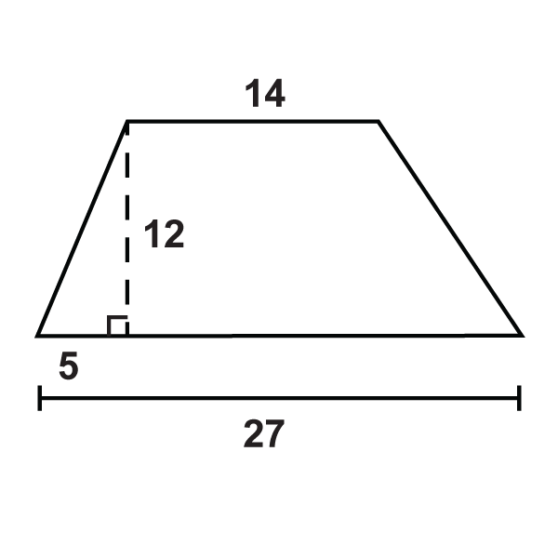
- What is the perimeter of the trapezoid?
- What is the area of the trapezoid?
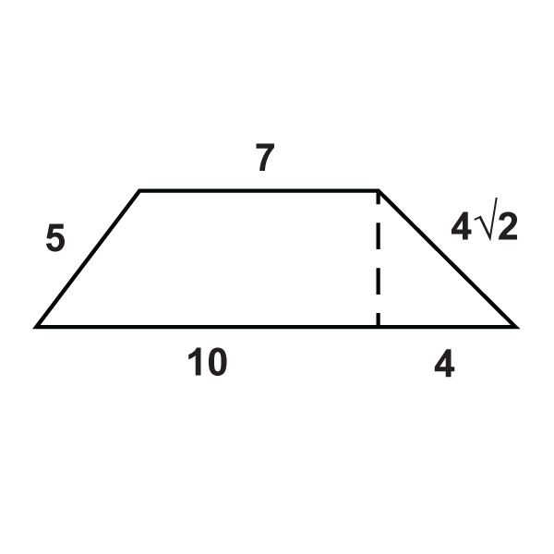
- What is the perimeter of the trapezoid?
- What is the area of the trapezoid?
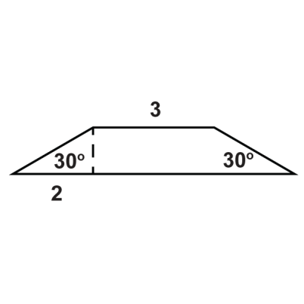
- What is the perimeter of the trapezoid?
- What is the area of the trapezoid?

Area and Perimeter of Rhombuses and Kites

Concept
In this concept, you will learn how to find the area and perimeter of kites and rhombuses.

Guidance
Recall that a rhombus is a quadrilateral with four congruent sides and a kite is a quadrilateral with distinct adjacent congruent sides. Both of these quadrilaterals have perpendicular diagonals, which is how we are going to find their areas.
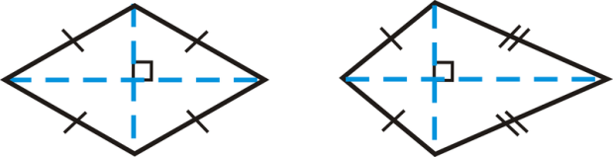
Notice that the diagonals divide each quadrilateral into 4 triangles. If we move the two triangles on the bottom of each quadrilateral so that they match up with the triangles above the horizontal diagonal, we would have two rectangles.
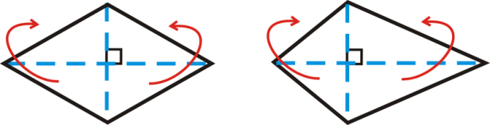
So, the height of these rectangles is half of one of the diagonals and the base is the length of the other diagonal. 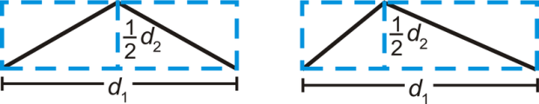
The area of a rhombus or a kite is 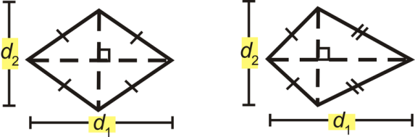

Example A
Find the perimeter and area of the rhombus below.
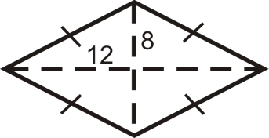
In a rhombus, all four triangles created by the diagonals are congruent.
To find the perimeter, you must find the length of each side, which would be the hypotenuse of one of the four triangles. Use the Pythagorean Theorem.

Example B
Find the perimeter and area of the rhombus below.
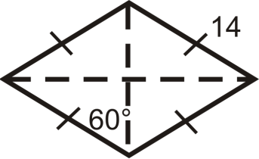
In a rhombus, all four triangles created by the diagonals are congruent.
Here, each triangle is a 30-60-90 triangle with a hypotenuse of 14. From the special right triangle ratios the short leg is 7 and the long leg is .

Vocabulary
Perimeter is the distance around a shape. The perimeter of any figure must have a unit of measurement attached to it. If no specific units are given (feet, inches, centimeters, etc), write “units.” Area is the amount of space inside a figure. Area is measured in square units. A rhombus is a quadrilateral with four congruent sides and a kite is a quadrilateral with distinct adjacent congruent sides.

Guided Practice
Find the perimeter and area of the kites below.
1. 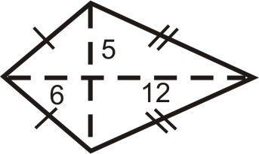

2. 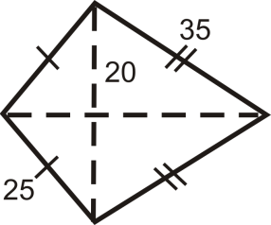

3. Find the area of a rhombus with diagonals of 6 in and 8 in.

Practice
- Do you think all rhombi and kites with the same diagonal lengths have the same area?Explain your answer.
Find the area of the following shapes. Round your answers to the nearest hundredth.
- 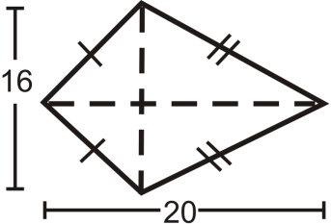
- 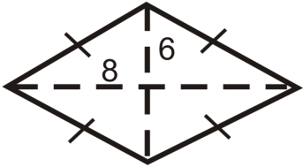
- 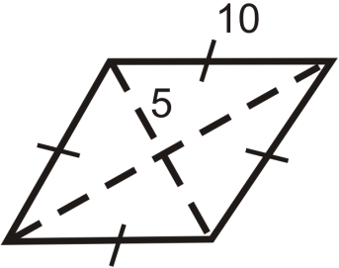
- 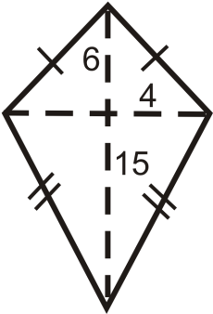
- 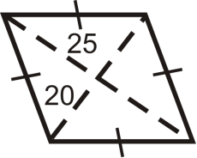
- 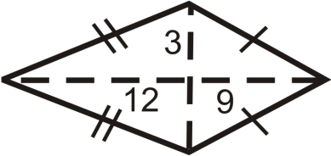

Find the area and perimeter of the following shapes. Round your answers to the nearest hundredth.
- 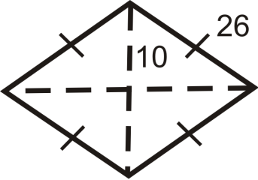

- 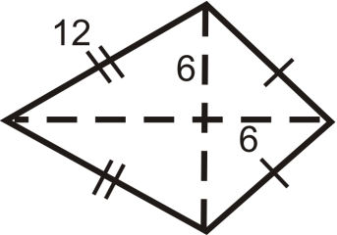

- 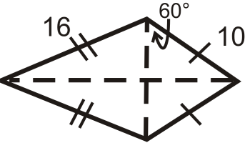
- 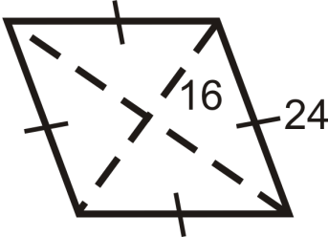
For Questions 12 and 13, the area of a rhombus is .
- What would the product of the diagonals have to be for the area to be ?
- List two possibilities for the length of the diagonals, based on your answer from #12.
For Questions 14 and 15, the area of a kite is .
- What would the product of the diagonals have to be for the area to be ?
- List two possibilities for the length of the diagonals, based on your answer from #14.
Sherry designed the logo for a new company, made up of 3 congruent kites.
- What are the lengths of the diagonals for one kite?
- Find the area of one kite.
- Find the area of the entire logo. 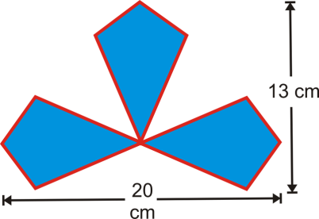

Area and Perimeter of Similar Polygons

Concept
In this concept, you will learn about the ratio between perimeters the ratio between areas of similar figures.

Guidance
Polygons are similar when their corresponding angles are equal and their corresponding sides are in the same proportion. Just as their corresponding sides are in the same proportion, perimeters and areas of similar polygons have a special relationship.
Perimeters: The ratio of the perimeters is the same as the scale factor. In fact, the ratio of any part of two similar shapes (diagonals, medians, midsegments, altitudes, etc.) is the same as the scale factor.
Areas: If the scale factor of the sides of two similar polygons is , then the ratio of the areas is (Area of Similar Polygons Theorem). You square the ratio because area is a two-dimensional measurement.

Example A
The two rectangles below are similar. Find the scale factor and the ratio of the perimeters and verify that the two results are the same.
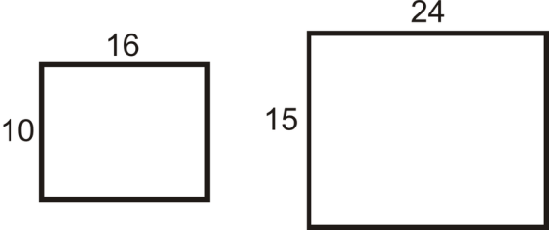
The scale factor is .
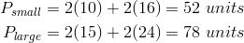
The ratio of the perimeters is .

Example B
Find the area of each rectangle from Example A. Then, find the ratio of the areas and verify that it fits the Area of Similar Polygons Theorem.
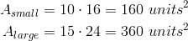
The ratio of the areas would be .
The ratio of the sides, or scale factor is and the ratio of the areas is . Notice that the ratio of the areas is the square of the scale factor.

Example C
Find the ratio of the areas of the rhombi below. The rhombi are similar.
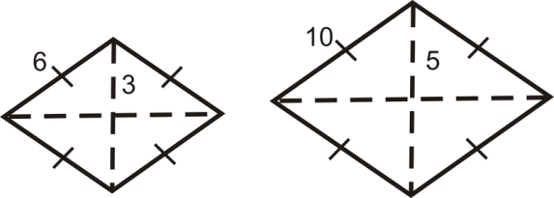
Find the ratio of the sides and square it.
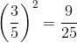

Vocabulary
Perimeter is the distance around a shape. The perimeter of any figure must have a unit of measurement attached to it. If no specific units are given (feet, inches, centimeters, etc), write “units.” Area is the amount of space inside a figure. Area is measured in square units. Polygons are similar when their corresponding angles are equal and their corresponding sides are in the same proportion. Similar polygons are the same shape but not necessarily the same size.

Guided Practice
1. Two trapezoids are similar. If the scale factor is and the area of the smaller trapezoid is , what is the area of the larger trapezoid?
2. Two triangles are similar. The ratio of the areas is . What is the scale factor?
3. Using the ratios from #2, find the length of the base of the smaller triangle if the length of the base of the larger triangle is 24 units.

Answers:
1. First, the ratio of the areas is . Now, we need the area of the larger trapezoid. To find this, set up a proportion using the area ratio.
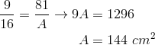
2. The scale factor is 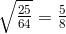.
3. Set up a proportion using the scale factor.
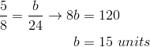

Practice
Determine the ratio of the areas, given the ratio of the sides of a polygon.
Determine the ratio of the sides of a polygon, given the ratio of the areas.
This is an equilateral triangle made up of 4 congruent equilateral triangles.
- What is the ratio of the areas of the large triangle to one of the small triangles?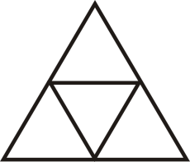
- What is the scale factor of large to small triangle?
- If the area of the large triangle is , what is the area of a small triangle?
- If the length of the altitude of a small triangle is , find the perimeter of the large triangle.
- Find the perimeter of the large square and the blue square.
- Find the scale factor of the blue square and large square.
- Find the ratio of their perimeters.
- Find the area of the blue and large squares.
- Find the ratio of their areas.
- Find the length of the diagonals of the blue and large squares. Put them into a ratio. Which ratio is this the same as?
- Two rectangles are similar with a scale factor of . If the area of the larger rectangle is , find the area of the smaller rectangle.
- Two triangles are similar with a scale factor of . If the area of the smaller triangle is , find the area of the larger triangle.
- The ratio of the areas of two similar squares is . If the length of a side of the smaller square is 24 units, find the length of a side in the larger square.
- The ratio of the areas of two right triangles is . If the length of the hypotenuse of the larger triangle is 48 units, find the length of the smaller triangle’s hypotenuse.
Questions 23-26 build off of each other. You may assume the problems are connected.
- Two similar rhombi have areas of and . Find the ratio of the areas.
- Find the scale factor.
- The diagonals in these rhombi are congruent. Find the length of the diagonals and the sides.
- What type of rhombi are these quadrilaterals?

Area of Composite Shapes

Concept
In this concept, you will learn how to find the area of composite shapes.

Guidance
Perimeter is the distance around a shape. The perimeter of any figure must have a unit of measurement attached to it. If no specific units are given (feet, inches, centimeters, etc), write “units.”
Area is the amount of space inside a figure. If two figures are congruent, they have the same area (Congruent Areas Postulate).
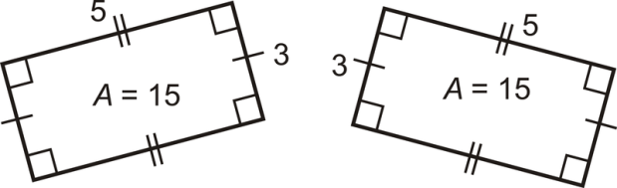
A composite shape is a shape made up of other shapes. To find the area of such a shape, simply find the area of each part and add them up.
Area Addition Postulate: If a figure is composed of two or more parts that do not overlap each other, then the area of the figure is the sum of the areas of the parts.

Example A
Find the area of the figure below.
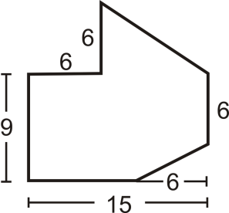
Divide the figure into a triangle and a rectangle with a small rectangle cut out of the lower right-hand corner.
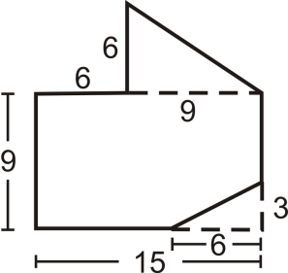

Example B
Divide the shape into two rectangles and one triangle. Find the area of the two rectangles and triangle:
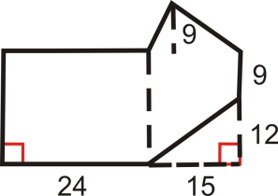
Rectangle #1:
Rectangle #2:
Triangle:

Example C
Find the area of the entire shape from Example B (you will need to subtract the area of the small triangle in the lower right-hand corner).

Vocabulary
Perimeter is the distance around a shape. The perimeter of any figure must have a unit of measurement attached to it. If no specific units are given (feet, inches, centimeters, etc), write “units.” Area is the amount of space inside a figure and is measured in square units. A composite shape is a shape made up of other shapes.

Guided Practice

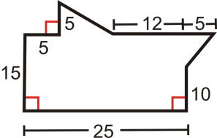
- Divide the shape into two triangles and one rectangle.
- Find the area of the two triangles and rectangle.
- Find the area of the entire shape.

Answers
1. One triangle on the top and one on the right. Rectangle is the rest.
2. Area of triangle on top is . Area of triangle on right is . Area of rectangle is .
3. Total area is .

Practice
Use the picture below for questions 1-4. Both figures are squares.
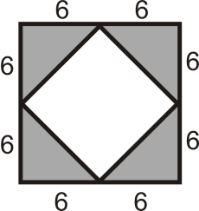
- Find the area of the outer square.
- Find the area of one grey triangle.
- Find the area of all four grey triangles.
- Find the area of the inner square.
Find the areas of the figures below. You may assume all sides are perpendicular.
- 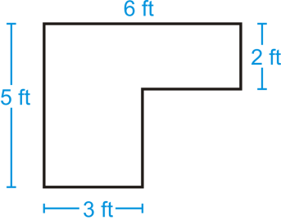
- 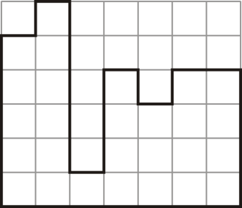
Find the areas of the composite figures.
- 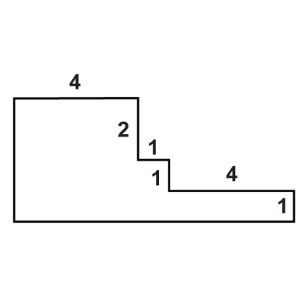
- 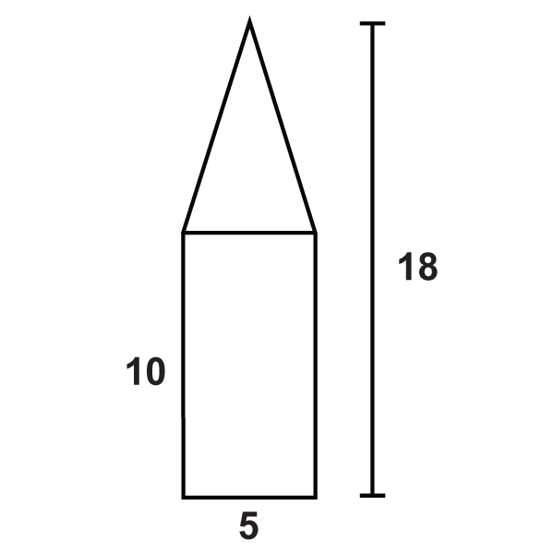
- 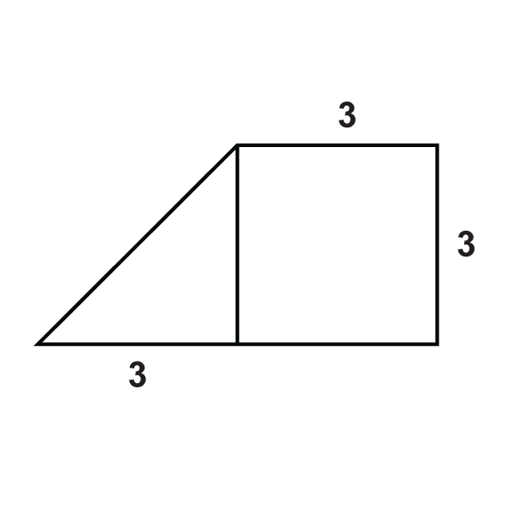
- 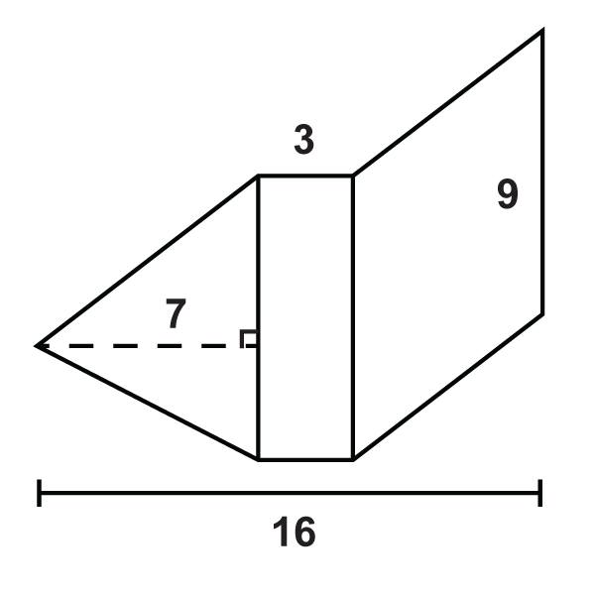
- 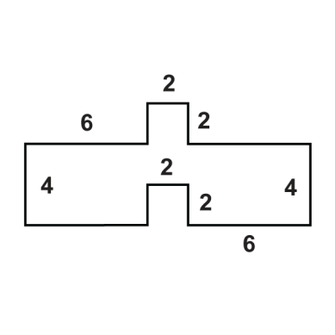
- 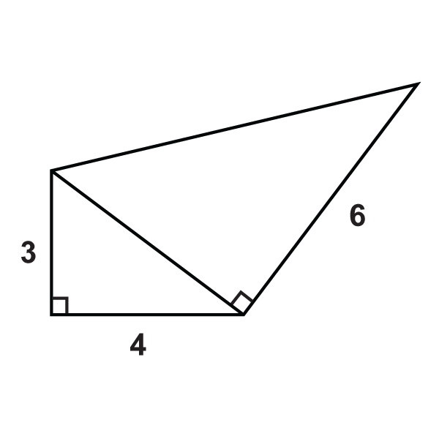
Use the figure to answer the questions.
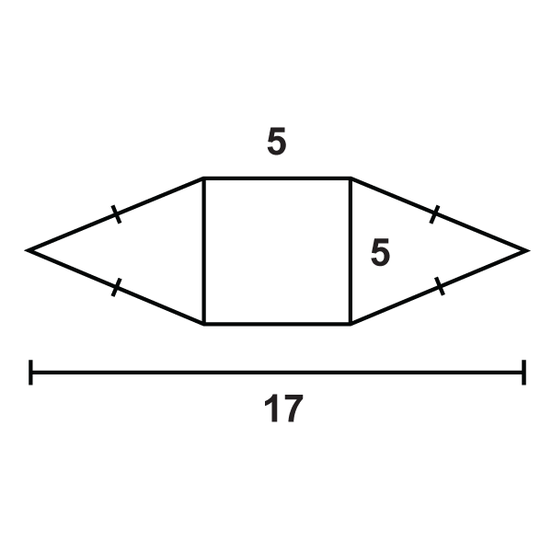
- What is the area of the square?
- What is the area of the triangle on the left?
- What is the area of the composite figure?
Circumference

Concept
In this concept, you will learn how to find the circumference of a circle.

Guidance
Circumference is the distance around a circle. The circumference can also be called the perimeter of a circle. However, we use the term circumference for circles because they are round.
Circumference Formula: where the diameter , or twice the radius. So as well.
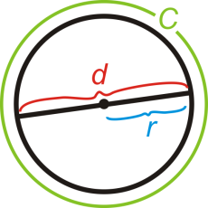
, or “pi” is the ratio of the circumference of a circle to its diameter. It is approximately equal to 3.14159265358979323846...
To see more digits of , go to http://www.eveandersson.com/pi/digits/. You should have a button on your calculator. If you don't, you can use 3.14 as an approximation for . You can also leave your answers in terms of for many problems.

Example A
Find the circumference of a circle with a radius of 7 cm.
Plug the radius into the formula.

Example B
The circumference of a circle is units. Find the diameter.
Again, you can plug in what you know into the circumference formula and solve for .
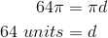

Example C
A circle is inscribed in a square with 10 in. sides. What is the circumference of the circle? Leave your answer in terms of .
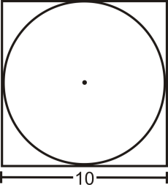
From the picture, we can see that the diameter of the circle is equal to the length of a side. .

Vocabulary
A circle is the set of all points that are the same distance away from a specific point, called the center. A radius is the distance from the center to the outer rim of the circle. A chord is a line segment whose endpoints are on a circle. A diameter is a chord that passes through the center of the circle. The length of a diameter is two times the length of a radius. Circumference is the distance around a circle. , or “pi” is the ratio of the circumference of a circle to its diameter.

Guided Practice
1. Find the perimeter of the square in Example C. Is it more or less than the circumference of the circle? Why?
2. The tires on a compact car are 18 inches in diameter. How far does the car travel after the tires turn once? How far does the car travel after 2500 rotations of the tires?
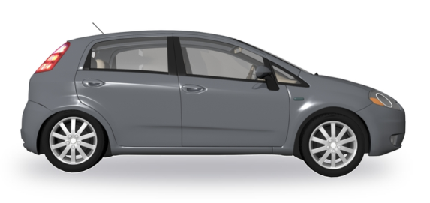
3. Find the radius of circle with circumference 88 in.

Answers:
1. The perimeter is . In order to compare the perimeter with the circumference we should change the circumference into a decimal.
. This is less than the perimeter of the square, which makes sense because the circle is inside the square.
2. One turn of the tire is the circumference. This would be . 2500 rotations would be , 11,781 ft, or 2.23 miles.
3. Use the formula for circumference and solve for the radius.
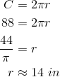

Practice
Fill in the following table. Leave all answers in terms of .
 | diameter | radius | circumference
1. | 15
2. |  | 4
3. | 6
4.
5. |  | 9
6.
7.
8. | 36
- Find the circumference of a circle with .
Square is inscribed in . .
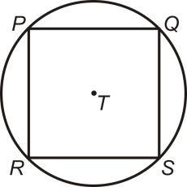
- Find the length of the diameter of .
- How does the diameter relate to ?
- Find the perimeter of .
- Find the circumference of .
For questions 14-17, a truck has tires with a 26 in diameter.
- How far does the truck travel every time a tire turns exactly once? What is this the same as?
- How many times will the tire turn after the truck travels 1 mile? (1 mile = 5280 feet)
- The truck has travelled 4072 tire rotations. How many miles is this?
- The average recommendation for the life of a tire is 30,000 miles. How many rotations is this?

