Finding an Angle in a Right Angled Triangle

You can find the Angle from Any Two Sides
We can find an unknown angle in a right-angled triangle, as long as we know the lengths of two of its sides.

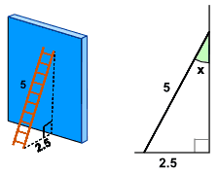

Example
A 5ft ladder leans against a wall as shown.
What is the angle between the ladder and the wall?
(Note: we also solve this on Solving Triangles by Reflection but now we solve it in a more general way.)
The answer is to use Sine, Cosine or Tangent!

But which one to use? We have a special phrase "SOHCAHTOA" to help us, and we use it like this:
Step 1: find the names of the two sides you know
- Adjacent is adjacent to the angle,  - Opposite is opposite the angle,  - and the longest side is theHypotenuse. | 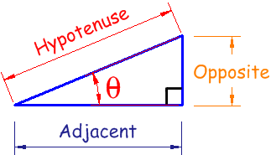
Example: in our ladder example we know the length of:
- the side Opposite the angle "x" (2.5 ft)
- the long sloping side, called the “Hypotenuse” (5 ft)
Step 2: now use the first letters of those two sides (Opposite and Hypotenuse) and the phrase "SOHCAHTOA" to find which one of Sine, Cosine or Tangent to use:
SOH... | Sine: sin(θ) = Opposite / Hypotenuse
...CAH... | Cosine: cos(θ) = Adjacent / Hypotenuse
...TOA | Tangent: tan(θ) = Opposite / Adjacent
In our example that is Opposite and Hypotenuse, and that gives us “SOHcahtoa”, which tells us we need to use Sine.
Step 3: Put our values into the Sine equation:
Sin (x) = Opposite / Hypotenuse = 2.5 / 5 = 0.5
Step 4: Now solve that equation!
sin (x) = 0.5
Next (trust me for the moment) we can re-arrange that into this:
x = sin⁻¹ (0.5)
And then get our calculator, key in 0.5 and use the sin⁻¹ button to get the answer:
x = 30°

What is sin⁻¹ ?
But what is the meaning of sin⁻¹ … ?
Well, the Sine function "sin" takes an angle and gives us the ratio “opposite/hypotenuse”,
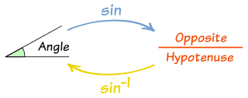
But in this case we know the ratio “opposite/hypotenuse” but want to know the angle.
So we want to go backwards. That is why we we use sin⁻¹, which means “inverse sine”.
Example:
- Sine Function: sin(30°) = 0.5
- Inverse Sine Function: sin⁻¹(0.5) = 30°

On the calculator you would press one of the following (depending on your brand of calculator): either '2ndF sin' or 'shift sin'.
On your calculator, try using "sin" and "sin⁻¹" to see what results you get!

Step By Step
These are the four steps we need to follow:
- Step 1 Decide which two sides we know – out of Opposite, Adjacent and Hypotenuse.
- Step 2 Use SOHCAHTOA to decide which one of Sine, Cosine or Tangent to use in this question.
- Step 3 Use your calculator to calculate the fraction Opposite/Hypotenuse, Adjacent/Hypotenuse orOpposite/Adjacent (whichever is appropriate).
- Step 4 Find the angle from your calculator, using one of sin⁻¹, cos⁻¹ or tan⁻¹

Examples
Let’s look at a couple more examples:
Example 1  Find the size of the angle of elevation  of the plane from point A on the ground. |  | 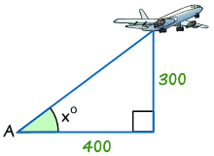
- Step 1 The two sides we know are Opposite (300) and Adjacent (400).
- Step 2 SOHCAHTOA tells us we must use Tangent.
- Step 3 Use your calculator to calculate Opposite/Adjacent = 300/400 = 0.75
- Step 4 Find the angle from your calculator using tan⁻¹
Tan x° = opposite/adjacent = 300/400 = 0.75
tan⁻¹ of 0.75 = 36.9° (correct to 1 decimal place)
Unless you’re told otherwise, angles are usually rounded to one place of decimals.

Example 2  Find the size of angle a° |  | 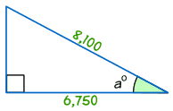
- Step 1 The two sides we know are Adjacent (6,750) and Hypotenuse (8,100).
- Step 2 SOHCAHTOA tells us we must use Cosine.
- Step 3 Use your calculator to calculate Adjacent / Hypotenuse = 6,750/8,100 = 0.8333
- Step 4 Find the angle from your calculator using cos⁻¹ of 0.8333:
cos a° = 6,750/8,100 = 0.8333
cos⁻¹ of 0.8333 = 33.6° (to 1 decimal place)

Finding a Side in a Right Angled Triangle

You can find a Side if you know another Side and Angle
We can find an unknown side in a right-angled triangle if we know:
- one length, and
- one angle (apart from the right angle, that is).
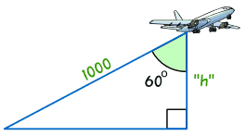 | Example  Find the height of the plane.
We know one length (1000) and one angle (60°), so we should be able to solve it, but how?
The answer is to use Sine, Cosine or Tangent!
But which one to use? We have a special phrase "SOHCAHTOA" to help us, and we use it like this:

Step 1: find the names of the two sides you are working on: the side you already know, and the side you are trying to find:
- Adjacent is adjacent to the angle,
- Opposite is opposite the angle,
- and the longest side is theHypotenuse.
In our example:
- the one we know is the Hypotenuse
- the one we are trying to find is Adjacent to the angle (check for yourself that "h" is adjacent to the angle 60°)
Step 2: now use the first letters of those two sides (Adjacent and Hypotenuse) and the phrase "SOHCAHTOA" to find which one of Sine, Cosine or Tangent to use:
SOH... | Sine: sin(θ) = Opposite / Hypotenuse
...CAH... | Cosine: cos(θ) = Adjacent / Hypotenuse
...TOA | Tangent: tan(θ) = Opposite / Adjacent
In our example that is Adjacent and Hypotenuse, and that gives us “sohCAHtoa”, which tells us we need to use Cosine.
Step 3: Put our values into the Cosine equation:
cos 60° = Adjacent / Hypotenuse = h / 1000
Step 4: Now solve that equation!
But how do we calculate "cos 60°" ... ?
You use your calculator! type in 60 and then use the "cos" key. That's easy!
cos 60° = 0.5 (by my calculator)
So now we can put "0.5" instead of "cos 60°":
0.5 = h / 1000
Now all that is left is to rearrange it a little bit:
Start with: |  | 0.5 = h / 1000
Swap sides: |  | h / 1000 = 0.5
Multiply both sides by 1000: |  | h = 0.5 x 1000 = 500
The height of the plane = 500 meters

Step By Step
These are the four steps to follow:
- Step 1 Decide which two sides we are using - one we are trying to find and one we already know – out of Opposite, Adjacent and Hypotenuse.
- Step 2 Use SOHCAHTOA to decide which one of Sine, Cosine or Tangent to use in this question.
- Step 3 Write down the fraction Opposite/Hypotenuse, Adjacent/Hypotenuse or Opposite/Adjacent, whichever is appropriate (one of the values will be the unknown length)
- Step 4 Solve using your calculator and your skills with Algebra

Examples
Let’s look at a few more examples:
Example: Find the length of the side a: |  | 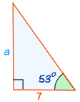

- Step 1 The two sides we are using are Opposite (a) and Adjacent (7).
- Step 2 SOHCAHTOA tells us we must use Tangent.
- Step 3 Write down the fraction for tan 53° = Opposite/Adjacent = a/7
- Step 4 Solve:
Start with: |  | tan 53° = a/7
Swap: |  | a/7 = tan 53°
Calculate tan 53°: |  | a/7 = 1.32704…
Multiply both sides by 7: |  | a = 1.32704… × 7 = 9.29 (to 2 decimal places)
Side "a" = 9.29

Example 2
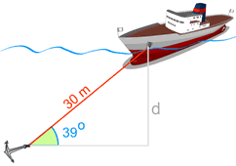 | The angle the cable makes with the seabed is 39° and the cable's length is 30 m.  Find the depth "d" that the anchor ring lies beneath the hole in the ship’s side.

- Step 1 The two sides we are using are Opposite (d) and Hypotenuse (30).
- Step 2 SOHCAHTOA tells us we must use Sine.
- Step 3 Write down the fraction for sin 39° = opposite/hypotenuse = d/30
- Step 4 Solve:
Start with: |  | sin 39° = d/30
Swap: |  | d/30 = sin 39°
Calculate sin 39°: |  | d/30 = 0.6293…
Multiply both sides by 30: |  | d = 0.6293… x 30 = 18.88 to 2 decimal places.
The depth the anchor ring lies beneath the hole is 18.88 m

Example 3
There is a mast that is 70 m high.  A wire goes to the top of the mast at an angle of 68°.  How long is the wire? | 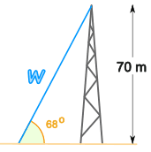
- Step 1 The two sides we are using are Opposite (70) and Hypotenuse (x).
- Step 2 SOHCAHTOA tells us we must use Sine.
- Step 3 Write down the fraction for sin 68° = 70/w
- Step 4 Solve:
The unknown length is on the bottom (the denominator) of the fraction!
So we need to follow a slightly different approach when solving :
Start with: |  | sin 68° = 70/w
Multiply both sides by w: |  | w × (sin 68°) = 70
Divide both sides by "sin 68°": |  | w = 70 / (sin 68°)
Calculate: |  | w = 70 / 0.9271... = 75.5 m (to 1 place)
The length of the wire = 75.5 m

Unit Circle
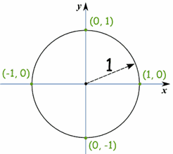 | The "Unit Circle" is just a circle with a radius of 1.  Being so simple, it is a great way to learn and talk about lengths and angles.  The center is put on a graph where the x axis and y axis cross, so we get this neat arrangement here.

Sine, Cosine and Tangent  Because the radius is 1, you can directly measure sine, cosine and tangent.  What happens when the angle, θ is 0°?  - cos=1, sin=0 and tan=0  What happens when θ is 90°?  - cos=0, sin=1 and tan is undefined | 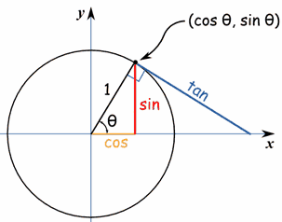

Important Angles: 30°, 45° and 60°
You should try to remember sin, cos and tan for the angles 30°, 45° and 60°.
Yes, yes, it is a pain to have to remember things, but it will make life easier when you know them, not just in exams, but other times when you need to do quick estimates, etc.
These are the values you should remember!
Angle | Sin | Cos | Tan=Sin/Cos
30° |  | 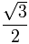 | ^{√3}/₃
45° | 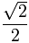 |  | 1
60° |  |  | √3

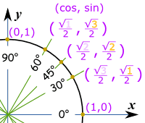How To Remember?
To help you remember, think "1,2,3" :
- sin(30°) = ^{√1}/₂ = ¹/₂ (because √1 = 1)
- sin(45°) = ^{√2}/₂
- sin(60°) = ^{√3}/₂
And cos goes "3,2,1"
- cos(30°) = ^{√3}/₂
- cos(45°) = ^{√2}/₂
- cos(60°) = ^{√1}/₂ = ¹/₂ (because √1 = 1)
What about tan? tan = sin/cos, so you think "tan of 60° is sin(60°)/cos(60°) = ^{√3}/₂ divided by ½ = √3"

Calculating 30°, 45° and 60°
Where did those values come from?
Well, we can use the equation x² + y² = 1 to find the lengths of x and y (which are equal to cos and sinwhen the radius is 1):
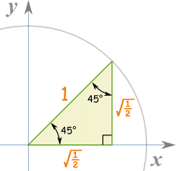 | 45 Degrees  For 45 degrees, x and y are equal, so y=x:  x² + x² = 1  2x² = 1  x² = ½  x = y = √½
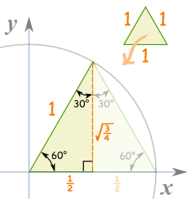 | 60 Degrees  Take an equilateral triangle (all sides are equal and all angles are 60°) and split it down the middle.  The "x" side is now ½,  And the "y" side will be:  (½)² + y² = 1  ¼ + y² = 1  y² = 1-¼ = ¾  y = √¾

30 Degrees
30° is just 60° with x and y swapped, so x = √¾ and y = ½

Summary
√½ is usually changed to this: |  | 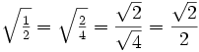
And √¾ is usually changed to this: |  | 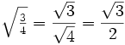
So we get the table we saw before:
Angle | Sin | Cos | Tan=Sin/Cos
30° |  |  | ^{√3}/₃
45° |  |  | 1
60° |  |  | √3

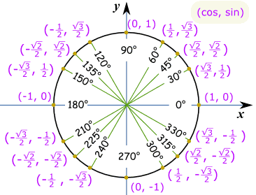
And this is the same Unit Circle in radians.
