Introduction to Trigonometry
Trigonometry (from Greek trigonon "triangle" + metron "measure")

Want to Learn Trigonometry? Here are the basics!
Follow the links for more, or go to Trigonometry Index

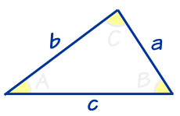 | Trigonometry ... is all about triangles.

Right Angled Triangle
A right-angled triangle (the right angle is shown by the little box in the corner) has names for each side:  - Adjacent is adjacent to the angle "θ",  - Opposite is opposite the angle, and  - the longest side is the Hypotenuse. | 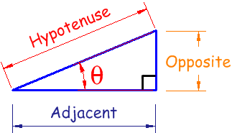

Angles
Angles (such as the angle "θ" above) can be in Degrees or Radians. Here are some examples:
Angle | Degrees | Radians
Right Angle | 90° | π/2
__ Straight Angle | 180° | π
Full Rotation | 360° | 2π

"Sine, Cosine and Tangent"
The three most common functions in trigonometry are Sine, Cosine and Tangent. You will use them a lot!
They are simply one side of a triangle divided by another.
For any angle "θ":
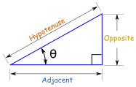 | Sine Function: sin(θ) = Opposite / Hypotenuse  Cosine Function: cos(θ) = Adjacent / Hypotenuse  Tangent Function: tan(θ) = Opposite / Adjacent

Example: What is the sine of 35°?
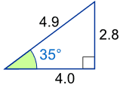 | Using this triangle (lengths are only to one decimal place):  sin(35°) = Opposite / Hypotenuse = 2.8/4.9 = 0.57...
Sine, Cosine and Tangent are often abbreivated to sin, cos and tan.

Try It!
Have a try! Drag the corner around to see how different angles affect sine, cosine and tangent
And you will also see why trigonometry is also about circles!
Notice that the sides can be positive or negative according to the rules of cartesian coordinates. This makes the sine, cosine and tangent vary between positive and negative also.

Unit Circle  What we have just been playing with is the Unit Circle.  It is just a circle with a radius of 1 with its center at 0.  Because the radius is 1, it is easy to measure sine, cosine and tangent. | 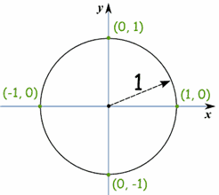
Here you can see the sine function being made by the unit circle:

Sine, Cosine and Tangent
Three Functions, but same idea.

Right Triangle
Sine, Cosine and Tangent are all based on a Right-Angled Triangle
Before getting stuck into the functions, it helps to give a name to each side of a right triangle:
- "Opposite" is opposite to the angle θ
- "Adjacent" is adjacent (next to) to the angle θ
- "Hypotenuse" is the long one
Adjacent is always next to the angle  And Opposite is opposite the angle | 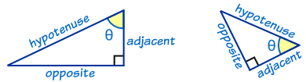

Sine, Cosine and Tangent
The three main functions in trigonometry are Sine, Cosine and Tangent.
They are often shortened to sin, cos and tan.
To calculate them:
Divide the length of one side by another side
... but you must know which sides!
For a triangle with an angle θ, the functions are calculated this way:
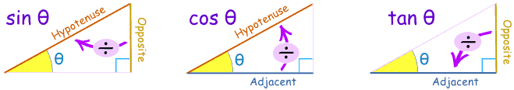
Sine Function: | sin(θ) = Opposite / Hypotenuse
Cosine Function: | cos(θ) = Adjacent / Hypotenuse
Tangent Function: | tan(θ) = Opposite / Adjacent

Example: What is the sine of 35°?
Using this triangle (lengths are only to one decimal place):
sin(35°) = Opposite / Hypotenuse = 2.8 / 4.9 = 0.57...
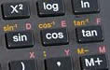 |  | Good calculators have sin, cos and tan on them, to make it easy for you. Just put in the angle and press the button.  But you still need to remember what they mean!

"Why didn't sin and tan go to the party?"
"... just cos!"

Examples

Example: what are the sine, cosine and tangent of 30° ?
The classic 30° triangle has a hypotenuse of length 2, an opposite side of length 1 and an adjacent side of √(3):
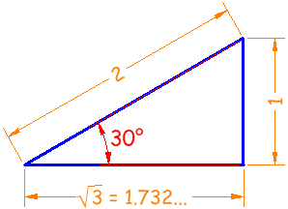
Now we know the lengths, we can calculate the functions:
Sine | sin(30°) = 1 / 2 = 0.5
Cosine | cos(30°) = 1.732 / 2 = 0.866...
Tangent | tan(30°) = 1 / 1.732 = 0.577...
(get your calculator out and check them!)

Example: what are the sine, cosine and tangent of 45° ?
The classic 45° triangle has two sides of 1 and a hypotenuse of √(2):
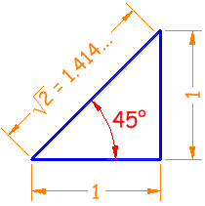
Sine |  |  | sin(45°) = 1 / 1.414 = 0.707...
Cosine |  |  | cos(45°) = 1 / 1.414 = 0.707...
Tangent |  |  | tan(45°) = 1 / 1 = 1

Try It!
Have a try! Drag the corner around to see how different angles (inradians or degrees) affect sine, cosine and tangent.
In this animation the hypotenuse is 1, making the Unit Circle.
Notice that the adjacent side and opposite side can be positive or negative, which makes the sine, cosine and tangent change between positive and negative values also.

Sohcahtoa
Sohca...what? Just an easy way to remember which side to divide by which! Like this:
Soh... | Sine = Opposite / Hypotenuse
...cah... | Cosine = Adjacent / Hypotenuse
...toa | Tangent = Opposite / Adjacent
You can read more about sohcahtoa ...
... but please remember "sohcahtoa" - it could help in an exam !

Why?
Why are these functions important?
- Because they let you work out angles when you know sides
- And they let you work out sides when you know angles
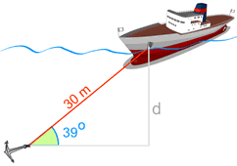
Example: Use the sine function to find "d"
We know
* The angle the cable makes with the seabed is 39°
* The cable's length is 30 m.
And we want to know "d" (the distance down).

Start with: |  | sin 39° = opposite/hypotenuse = d/30
Swap Sides: |  | d/30 = sin 39°
Use a calculator to find sin 39°: |  | d/30 = 0.6293…
Multiply both sides by 30: |  | d = 0.6293… x 30 = 18.88 to 2 decimal places.
The depth "d" is 18.88 m

Exercise
Try this paper-based exercise where you can calculate the sine function for all angles from 0° to 360°, and then graph the result. It will help you to understand these relatively simple functions.
You can also see Graphs of Sine, Cosine and Tangent.

Less Common Functions
To complete the picture, there are 3 other functions where you divide one side by another, but they are not so commonly used.
They are equal to 1 divided by cos, 1 divided by sin, and 1 divided by tan:
Secant Function: | sec(θ) = Hypotenuse / Adjacent | (=1/cos)
Cosecant Function: | csc(θ) = Hypotenuse / Opposite | (=1/sin)
Cotangent Function: | cot(θ) = Adjacent / Opposite | (=1/tan)

