The Law of Sines
The Law of Sines (or Sine Rule) is very useful for solving triangles:
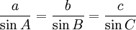
It works for any triangle:
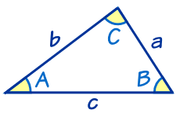 | a, b and c are sides.  A, B and C are angles.  (Side a faces angle A,  side b faces angle B and  side c faces angle C).
So if you divide side a by the sine of angle A it is equal to side b divided by the sine of angle B, and also equal to side c divided by the sine of angle C

Sure ... ?
Well, let's do the calculations for a triangle I prepared earlier:
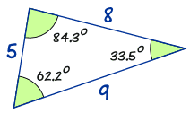 | a/sin A = 8 / sin (62.2°) = 8 / 0.885... = 9.04...  b/sin B = 5 / sin (33.5°) = 5 / 0.552... = 9.06...  c/sin C = 9 / sin (84.3°) = 9 / 0.995... = 9.05...
The answers are almost the same!
(They would be exactly the same if I used perfect accuracy).
So now you can see that:
a/sin A = b/sin B = c/sin C

How Do I Use It?
Let us see an example:

Example: Calculate side "c"
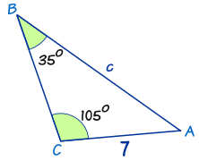

Law of Sines: |  | a/sin A = b/sin B = c/sin C
Put in the values we know: |  | a/sin A = 7/sin(35°) = c/sin(105°)
Ignore a/sin A (not useful to us): |  | 7/sin(35°) = c/sin(105°)
Now we use our algebra skills to rearrange and solve:
Swap sides: |  | c/sin(105°) = 7/sin(35°)
Multiply both sides by sin(105°): |  | c = ( 7 / sin(35°) ) × sin(105°)
Calculate: |  | c = ( 7 / 0.574... ) × 0.966...
Calculate: |  | c = 11.8 (to 1 decimal place)

Finding an Unknown Angle
In the previous example we found an unknown side ...
... but we can also use the Law of Sines to find an unknown angle.
In this case it is best to turn the fractions upside down (sin A/a instead of a/sin A, etc):
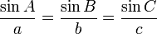

Example: Calculate angle B
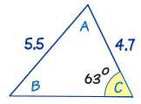

Start with: |  | sin A / a = sin B / b = sin C / c
Put in the values we know: |  | sin A / a = sin B / 4.7 = sin(63º) / 5.5
Ignore "sin A / a": |  | sin B / 4.7 = sin(63º) / 5.5
Multiply both sides by 4.7: |  | sin B = (sin63º/5.5) × 4.7
Calculate: |  | sin B = 0.7614...
Inverse Sine: |  | B = sin⁻¹(0.7614...)
 |  | B = 49.6º

Sometimes There Are Two Answers !
There is one very tricky thing you have to look out for:
Two possible answers.
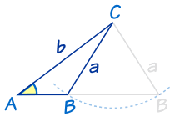 | Let us say you know angle A, and sides a and b.  You could swing side a to left or right and come up with two possible results (a small triangle and a much wider triangle)  Both answers are right!
This only happens in the "Two Sides and an Angle not between" case, and even then not always, but you have to watch out for it.
Just think "could I swing that side the other way to also make a correct answer?"

Example: Calculate angle R
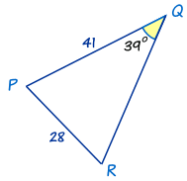

The first thing to notice is that this triangle has different labels: PQR instead of ABC. But that's not a problem. We just use P,Q and R instead of A, B and C in The Law of Sines.
Start with: |  | sin R / r = sin Q / q
Put in the values we know: |  | sin R / 41 = sin(39º)/28
Multiply both sides by 41: |  | sin R = (sin39º/28) × 41
Calculate: |  | sin R = 0.9215...
Inverse Sine: |  | R = sin⁻¹(0.9215...)
 |  | R = 67.1º

But wait! There's another angle that also has a sine equal to 0.9215...
Your calculator won't tell you this but sin(112.9º) is also equal to 0.9215... (try it!)
So ... how do you discover the vale 112.9º?
Easy ... take 67.1º away from 180°, like this:
180° - 67.1° = 112.9°
So there are two possible answers for R: 67.1º and 112.9º:
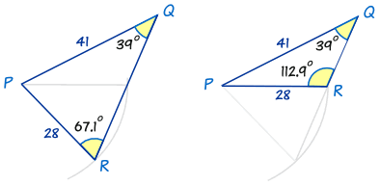
Both are possible! Each one has the 39º angle, and sides of 41 and 28.
So, always check to see whether the alternative answer makes sense.
- ... sometimes it will (like above) and there will be two solutions
- ... sometimes it won't (see below) and there is one solution
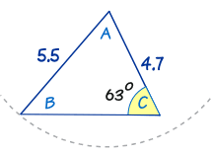 | We looked at this triangle before.  As you can see, you can try swinging the "5.5" line around, but no other solution makes sense.  So this has only one solution.

The Law of Cosines
The Law of Cosines (also called the Cosine Rule) is very useful for solving triangles:
It works for any triangle:
a, b and c are sides.
C is the angle opposite side c
Let's see how to use it in an example:

Example: How long is side "c" ... ?

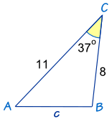
We know angle C = 37º, a = 8 and b = 11
The Law of Cosines says: |  | c² = a² + b² - 2ab cos(C)
Put in the values we know: |  | c² = 8² + 11² - 2 × 8 × 11 × cos(37º)
Do some calculations: |  | c² = 64 + 121 - 176 × 0.798…
Which gives us: |  | c² = 44.44...
Take the square root: |  | c = √44.44 = 6.67 (to 2 decimal places)
Answer: c = 6.67

How to Remember
How can you remember the formula?
Well, it helps to know that it is the Pythagoras Theorem with something extra so it works for all triangles:
Pythagoras Theorem: |  | a² + b² = c² |  | (only for Right-Angled Triangles)
Law of Cosines: |  | a² + b² - 2ab cos(C) = c² |  | (for all triangles)
So, to remember it:
- think "abc": a² + b² = c²,
- then another "abc": 2ab cos(C),
- and put them together: a² + b² - 2ab cos(C) = c²

When to Use
The law of cosines is useful for finding:
- the third side of a triangle when you know two sides and the angle between them (like the example above)
- the angles of a triangle when you know all three sides (as in the following example)

Example: What is Angle "C" ...?
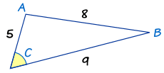
The side of length "8" is opposite angle C, so it is side c. The other two sides are a and b.
Now let us put what we know into The Law of Cosines:
Start with: |  | c² = a² + b² - 2ab cos(C)
Put in a, b and c |  | 8² = 9² + 5² - 2 × 9 × 5 × cos(C)
Calculate: |  | 64 = 81 + 25 - 90 × cos(C)
Calculate some more: |  | 64 = 106 - 90 × cos(C)
Now we use our algebra skills to rearrange and solve:
Subtract 64 from both sides: |  | 0 = 42 - 90 × cos(C)
Add "90 × cos(C)" to both sides: |  | 90 × cos(C) = 42
Divide both sides by 90: |  | cos(C) = 42/90
Inverse cosine: |  | C = cos⁻¹(42/90)
Calculator: |  | C = 62.2° (to 1 decimal place)

In Other Forms

Easier Version For Angles
There is a version that is easier to use when finding angles. It is simply a rearrangement of the c² = a² + b² - 2ab cos(C) formula like this:
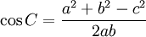

Example: Find Angle "C"
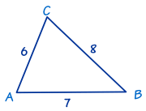
In this triangle we know the three sides:
- a = 8,
- b = 6 and
- c = 7.

Use The Law of Cosines (angle version) to find angle C :
cos C = (a² + b² - c²)/2ab
= (8² + 6² - 7²)/2×8×6 = (64 + 36 - 49)/96 = 51/96 = 0.53125
C = cos⁻¹(0.53125)
= 57.9° correct to one decimal place.

Versions for a, b and c
Also, you can rewrite the c² = a² + b² - 2ab cos(C) formula into "a²=" and "b²=" form.
Here are all three:
But it is easier to remember the "c²=" form and change the letters as needed !
As in this example:

Example: Find the distance "z"
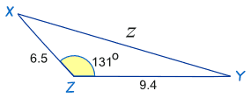
The letters are different! But that doesn't matter. We can easily substitute x for a, y for b and z for c
Start with: |  | c² = a² + b² - 2ab cos(C)
x for a, y for b and z for c |  | z² = x² + y² - 2xy cos(Z)
Put in the values we know: |  | z² = 9.4² + 6.5² - 2×9.4×6.5×cos(131º)
Calculate: |  | z² = 88.36 + 42.25 - 122.2×(-0.656...)
 |  | z² = 130.61 + 80.17...
 |  | z² = 210.78...
 |  | z = √210.78... = 14.5 to 1 decimal place.

Answer: z = 14.5

Did you notice that cos(131º) is negative and this changes the last sign in the calculation to +(plus)? The cosine of an obtuse angle is always negative (see Unit Circle).

